TTSWG Inaugural Sip & Tech Event Communique
December 2022

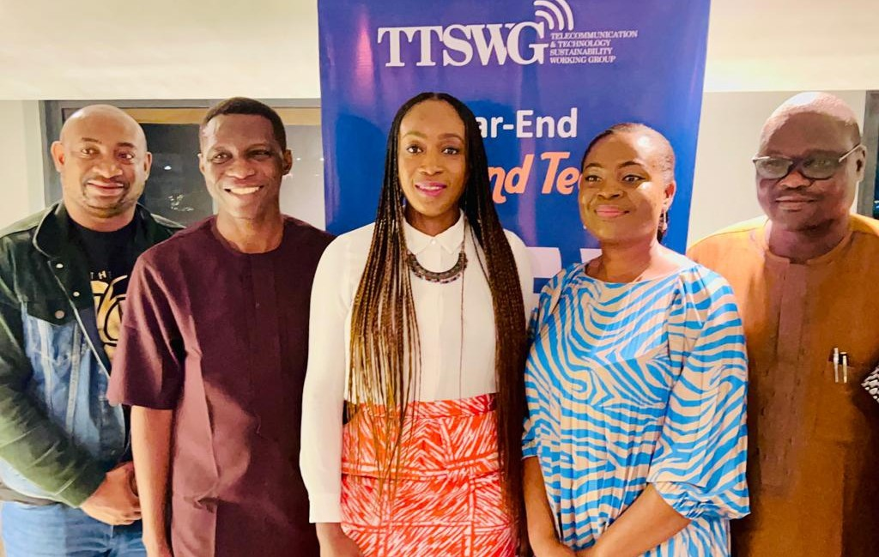On Wednesday, 21 December 2022, the Telecommunication and Technology Sustainability Working Group (TTSWG), comprising of member organisations such as MTN Nigeria, IHS Nigeria Limited, HP Nigeria, S m i l e C o m m u n i c a t i o n s , B a c k b o n e Connectivity, Phase3Telecom, ALTON, amongst others, organised an end-of-year 'Sip & Tech' event with the aim of providing a platform for conversations among members, prospective members, and stakeholders in the ICT sector on promoting sustainability. The two-hour evening symposium dwelled largely on how telecoms and technology sector stakeholders can align themselves to entrenching sustainability in the sector especially as it relates to Environment, Social & Governance (ESG) matters, and possible collaboration on creating a sector-wide appreciation for sustainability.

The ICT sector in Nigeria is widely regarded as the 'next oil' as in Q2 2022 it contributed over 18% to the GDP in 2022, which was more than the contribution of the oil and ﬁnance & insurance sectors put together. This fact is underpinned by the emergence of tech companies worth over $1bn in Africa, often termed 'unicorns.' Currently, Nigeria houses ﬁve of Africa's seven unicorns, hence it holds the attention of venture capital investors as all indications point to the fact that Nigeria is cresting into an era of tech-driven economic growth.

In Nigeria's nascent years, she enjoyed a similar inﬂux of global capital and economic growth thanks to the oil sector, albeit with a sustainability void. This void eventually birthed severe ESG complications that the nation is yet to recover from. Thus, in a bid to avoid a repeat of the past, it is imperative that conversations around sustainability be promoted now in the ICT sector and followed through with deﬁnitive collaborative action to
‘
In a bid to avoid a repeat of the past, it is imperative that conversations around sustainability be promoted now in the ICT sector and followed through with deﬁnitive collaborative action to entrench sustainability in the sector. Hence,
the rationale for the Sip & Tech
event.
‘

entrench sustainability in the sector. Hence, the rationale for the Sip & Tech event.

Held at the serene Chapter Lagos Restaurant, Victoria Island, Lagos, the event was well attended by TTSWG member organisations, prospective members and stakeholders in the ICT sector including: John Isiekwene, Manager, Sustainability, IHS Towers; Edward Fagbohun, Manager, Sustainability & Impact Reporting, MTN Foundation; Elizabeth Nwajei, Partner Business Manager, HP Inc.; Oluwole Asalu, Founder & Chief Executive, Quomodo Systems; Olurotimi Ige, Enterprise Account Manager, Amazon Web Services Nigeria, Chineze Amanfo, Lead Public Relations, 9Mobile; Gbolahan Awonuga, Executive Secretary, Association of Licensed Telecoms Operators of Nigeria (ALTON).

Discussion Points
Some critical points highlighted during the Sip & Tech event are:

- Inclusion of the younger generation: It was raised that global tech organisations like Microsoft are now looking into young tech talents to enrich their talent base, hence, sustainability planning should embrace bridging the gap between generations and getting more young people involved in driving sustainability within the ICT sector in Nigeria.

- Sustainability is about responsibility and ownership: Businesses and stakeholders in the ICT sector must become more proactive about being responsible for sustainability by incorporating ESG into their operations and management. There was an emphasis on owning the drive for sustainability across the business value

chains by providing incentives to inﬂuence the adoption of more climate-friendly and s u s t a i n a b l e p r a c t i c e s b y v e n d o r s / b u s in e s s e s a c r o s s e a c h organisation's value chain. Businesses n e e d t o s t a r t w h e r e t h e y a r e b y i n c o r p o r a t i n g i n t e n t i o n a l E S G management into their operations.

- Harmonisation of government policies governing the sector: In its role as regulator, the government has the responsibility to create an enabling environment for entrenching sustainability in the ICT sector. Policies governing the sector need to be harmonized and geared towards promoting sustainability. Hence there must be wide consultation and collaboration to achieve a fair and inclusive policy.

- Nigeria's ICT sector needs to be innovative in interpreting sustainability: While Africa contributes the least to global CO2 emissions, the continent is one of the hardest hit by the eects of global warming. Businesses must be focused not only on their environmental impacts, but also in their social and governance impacts.

- Partnership is key to entrenching sustainability in the ICT sector: The sector plays host to various stakeholders ranging from Operators, Original Equipment Manufacturer (OEM), Value Added Service Providers (VAS), TowerCo, Academia, Civil Society, Regulators, and Technology Services. There is a need for collaboration among these stakeholders to promote sustainability in the sector and establish a set of standards that govern sustainability.

- Sustainability is proﬁtable: A major hurdle to the adoption of sustainability by businesses is the untrue perception that it is a luxury that businesses can ill aord. In reality, sustainability is proﬁtable as it positions compliant organisations to receive Foreign Direct Investment (FDI) from investors who are concerned about ESG matters. The drive to promote sustainability must create awareness a m o n g th e m a n a g e m e n t c a d r e o f businesses in the sector that money can be made ethically.

- Sustainability reporting and certiﬁcation can enhance the process: Sustainability reporting and certiﬁcation like the GRI Reporting Standards should be widely adopted, to encourage businesses to adopt sustainability.

Summarily, driving sustainability in the ICT sector must be a collaborative eort primarily between businesses, their suppliers/partners, regulators and the government, in order to succeed.

Recommendations

The various recommendations include:

- Training & inclusion of young people: It is vital that young people are trained in tech skills; particularly the girl-child who is the least represented in STEM disciplines. This will prepare them to play a role in driving sustainability in the sector. In this respect TTSWG has signed MoUs with three Nigerian universities and is working with its member organisations on a quota system for internships and secondments of young university students to promote learning and development for the younger generation.

- Impact investing: Businesses may consciously engage in impact investing across their value chain to encourage sustainability, especially around ESG issues. A notable example being Amazon's investing in Rivian, an electric van company.

- Government should create an enabling environment: As the ICT sector continues to grow its contribution to the economy, government has a responsibility to create an enabling environment for promoting sustainability through fair regulations, standard setting, and enforcement across the industry.

- Businesses in the ICT sector should align with the UN-SDGs: Businesses should identify United Nations Sustainable Development Goals (SDGs) and national priorities that are relevant to their operations and should align with it in their goal setting, business planning and operations.

- Collaborative advocacy: Stakeholders in the sector must team-up in advocacy to ensure that the entire sector adopts a sustainability-mindset and standards that will ensure the long-term viability of the ICT sector in Nigeria.

- C-suite support: The drive for sustainability will be eective if it has the buy-in of the top management within businesses who can inﬂuence their business structures and operations to enhance sustainability. They can also play a key role in promoting sustainability-thinking amongst their sta.

TTSWG continues to promote sustainability in th e s e c to r b y p r o v id in g t r a in in g to stakeholders, publications on the multi- faceted nature of sustainability as it relates to ICT, internships and secondments program, an upcoming Innovation Makers Challenge, and leading the co-creation of sustainability standards for Nigeria's ICT sector.

The TTSWG was encouraged to intensify advocacy and engagement towards reaching more stakeholders in the industry and providing a platform for them to collaborate on sustainability in the ICT sector.

About the TTSWG
The TTSWG is a multi-stakeholder network of corporate organisations committed to the development of the telecoms and technology sector through global best practices, innovation and thought leadership in business sustainability. It is aimed at yielding joint action among key stakeholders through various strategic partnerships, policy formulation and advocacy programmes.

Signed for TTSWG:

Bekeme Masade-Olowola Lead Consultant

